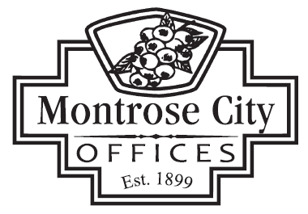

139 S. SAGINAW STREET MONTROSE, MI 48457 / PHONE (810) 639-6168

DOWNTOWN DEVELOPMENT AUTHORITY BOARD (D.D.A.)
December 18, 2025 @ 7:30 a.m.
CALL TO ORDER
ROLL CALL
PLEDGE OF ALLEGIANCE
APPROVAL OF AGENDA
CITIZEN COMMENTS
The purpose of this agenda item is to allow persons to comment. This is not a forum for debate or for which questions will be answered. The Board will consider all comments and questions and decide if they wish to address those items during board comments. All persons addressing the DDA Board are asked to limit their comments to no more than three (3) minutes.

CONSENT AGENDA
- Approval of November 20, 2025, D.D.A. Meeting Minutes
- Receive and File Budget Update

PRESENTATION

OLD BUSINESS
NEW BUSINESS
- Consider Discussion on Proposed CIP

BID AWARD/PURCHASE

ORDINANCES

APPOINTMENTS

CITIZEN COMMENTS
The purpose of this agenda item is to allow persons to comment. This is not a forum for debate or for which questions will be answered. The Board will consider all comments and questions and decide if they wish to address those items during board comments. All persons addressing the DDA Board are asked to limit their comments to no more than three (3) minutes.

DDA COMMITTEE REPORTS
CITY MANAGER / DDA BOARD MEMBER COMMENTS
ADJOURNMENT
Next DDA Meeting – January 16, 2025 & 7:30 a.m.

